**3 Setting up difference equations (Measles)**

Set up the SEIR model of the transmission dynamics of measles in a closed population using difference equations:



St+1 =St –β∗St ∗It

Et+1 =Et +β∗St ∗It −f ∗Et

It+1 =It +f ∗Et −r∗It

Rt+1 = Rt + r ∗ It

We assume that individuals mix randomly and parameter values are given as follows:

Population 100,000 people

Pre-infectious period 8 days

Infectious period 7 days

Basic reproduction number 13

Life Expectancy 70 years

Initial values (S,E,I,R)=(99999,0,1,0)

**PART I: Setting up difference equations**

1. Plot a graph for number of susceptible, pre-Infectious, infectious, and recovered populations during 200 days.

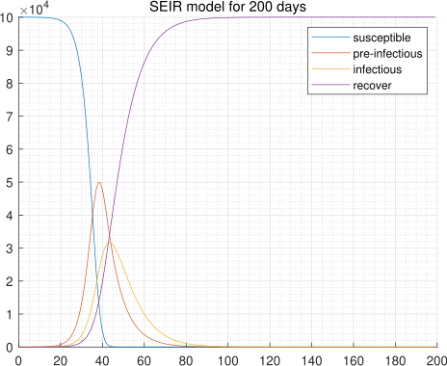

1. How long does it take before there are no infectious persons in the population?   
   **Ans : Eradication occurs on the 137th day.**

Why do no further new infectious persons occur in this population after a certain time?

**Ans : Because everyone has immunity. There are no new susceptible individuals in the population.**

1. How does the graph change if you change the pre-infectious period to be 5 days and 20 days, respectively?

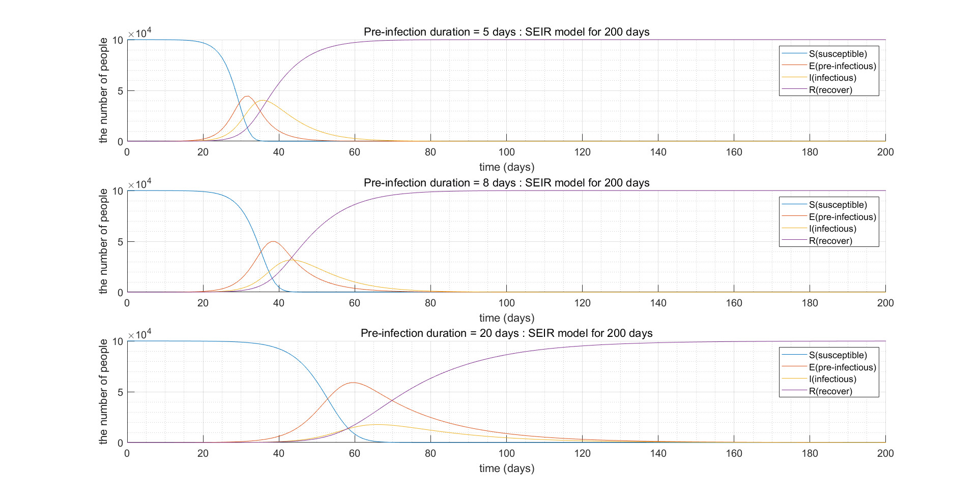

**Ans : The longer the pre-infection period, the slower the number of infections increases. In addition, it takes a long time to reduce the number of infections to zero when the pre-infection period is long.**

1. Which assumptions would you alter or add to the model to describe the transmission of measles in a large population over a period of years?  
   **- Births and deaths  
   - age structures  
   - change of population size  
   - migrants**

**PART Ⅱ: Incorporating births and deaths**

Modify the model to include the births and deaths in each time step and change the parameter values back to original:

1. Assuming that the population size doesn’t change over time, what would be an appropriate expression for the per capita birth rate and death rate?  
   **Ans : birth rate = death rate = 1 / life expectancy**
2. Is it realistic that all individuals are born into the susceptible population?  
   **Ans : No. we consider maternal immunity or transmission through pregnancy.**  
   Is this a reasonable assumption to make?   
   **Ans : It is reasonable assumption to make, because infants with maternal immunity are relatively small in total population, and so they don’t contribute much to the dynamics considered in model.**  
   What alternative assumptions might be appropriate to make the model more realistic?  
   **Ans : we can add another ‘compartment’ before ‘susceptible compartment’.**
3. With the birth and death rates included in the equations, run the equations for 200 days.  
   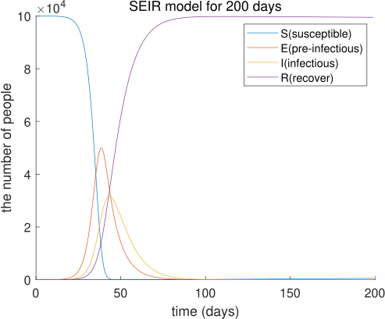  
   Is there a point where no more infections occur?   
   **Ans : Eradication occurs on the 140th day.**   
   What about 10 years? 50 years?  
   **Ans : They are also similar to Q2. More susceptible individuals are being added into the population, and at a certain point, an outbreak occurs**
4. How are the changes in the number of susceptible and immune related if you were to simulate the dynamics of measles for 50 years and for 100 years?  
   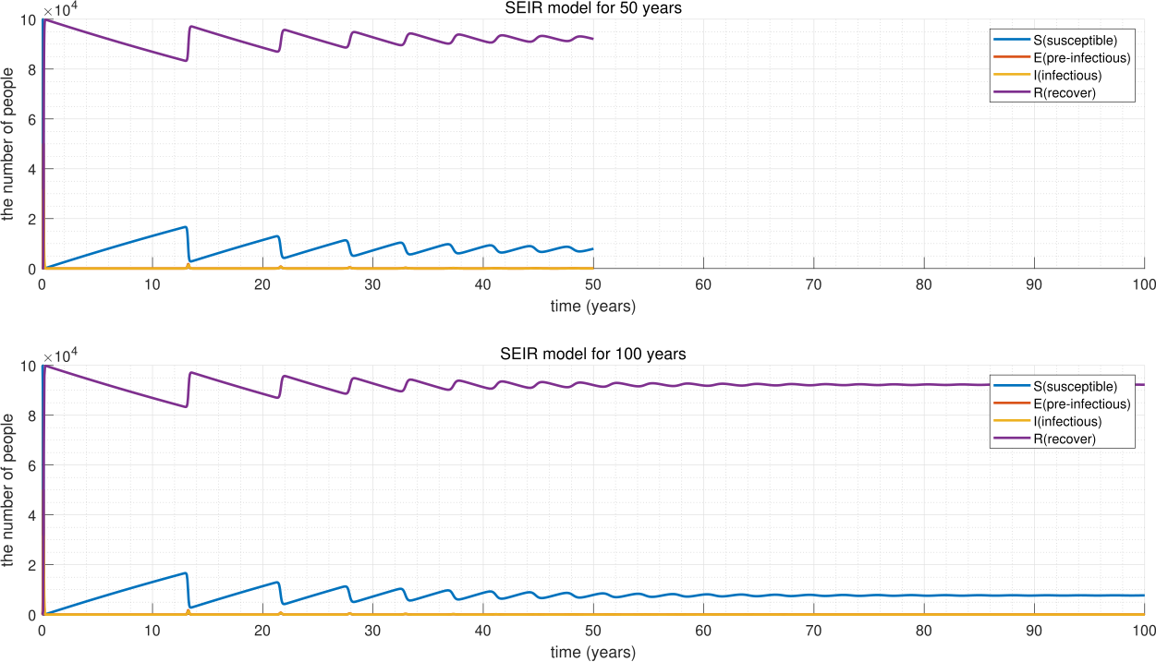
5. What happens if you change the time step to 2, 3, 4, and 5 days?

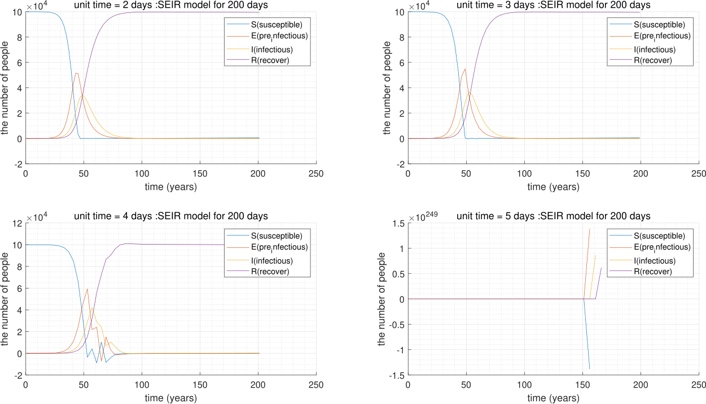

Would it be reasonable to take a time step of 10 days?

**Ans : No. a time step of 10 days will not run, because 10 days is longer than duration.**